Kingdom’s Saviour

10 Page Design Document

**Isabel Pijnenburg  
Sander Theeuwen**

PC, Rated M for Mature

To be released on date

# Story

You, the king’s knight, are sent on a quest to kill a mighty dragon. The dragon has terrorized the kingdom for ages, but now it is time to end it once and for all! You will travel through cities, villages, and forests to get to the dragon’s lair. Armed with a sword and a bow, you shoot any monster that stands in your way. During your adventure you will get items and weapons to help you along. Occasionally, you also encounter a merchant, with whom you can trade gold gained from killing monsters in return for items and/or weapons. Can you kill the dragon and restore peace in the kingdom?

# Gameplay

In Kingdom’s Saviour, the player is a knight going on an adventure to kill a dragon. The player encounters enemies such as orcs, which they need to kill to proceed with their quest. There are four levels, each one having the same structure except the final level. The main levels start with a horde of enemies, having a relatively low difficulty in comparison to the level. As a midway point, you encounter a merchant who sells you items and weapons. Because you are stronger after trading with the merchant, the second half of the level contains more difficult enemies, be it through more health, more damage, or other aspects. The final level, the dragon’s lair, does not have a merchant (seems logical). Instead, you travel through the volcano to the dragon.

# Game Flow

The player starts in the kingdom where they are told to go to the dragon’s lair. The first level, the city, contains a small amount of enemies so the player can figure out the controls and get a feeling on how to play the game. As the game progresses, the levels get more difficult in general (regardless of the internal difficulty curve of the individual levels). As the player gets closer to the destination, there are more enemies, with more health and attack damage.

# Fantasy Knight transparent PNG - StickPNGCharacters

**The knight** is the main character, the player’s avatar, and the chosen one to go on the adventure. To give the player the feeling that they *are* the knight, they do not have a name and are not shown in the game except for the weapons they hold and armor they wear. They do not speak and only make sounds when getting hurt.

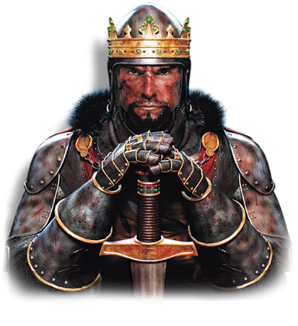**The king** rules the kingdom, though this is a difficult task with the dragon at large. He is the one sending the knight to slay the dragon.

# Controls

## Adventure

|  |  |
| --- | --- |
| Left mouse button | Use currently selected item |
| Right mouse button | Prepare currently selected item (bow) |
| Scroll wheel | Cycle through weapons |
| Numbers | Select specific weapon |

## Shop

|  |  |
| --- | --- |
| Left mouse button | Buy |
| A | Move left |
| D | Move right |

# Main Gameplay Concepts

The game has a camera that moves on its own, which also means they cannot move themselves. This lets the player focus more on the enemies instead of where they are going. A level consists of a singular route (straight), so the player always sees the enemies coming before they get to the player. As the player proceeds in the game, the route gets more dynamic, adding curves and hills. This way, the player can’t always see the monsters coming towards them. Enemies’ positions are not set and can be random anywhere on the screen. Enemies, with an exception for the dragon, can be killed with one or a few shots with the bow or other weapons (each one having their own damage value).

# Game World

## Setting

The game takes place in a medieval kingdom, filled with many houses and a castle. This is the intro for the story.  
The first level is set in the cities surrounding the kingdom. Because these are still densely populated, there are only a few monsters.  
The second level contains small villages, indicating the player is travelling further from the kingdom.  
The third level takes place in a forest, having no room for villages and being the home of many monsters.  
The last level is set in a volcano, where the player encounters the dragon’s lair in the end. The volcano contains many difficult monsters.

## Mood

As the game is about adventure, slaying enemies and a dragon, the mood can be defined as ‘heroic’. An epic battle with the dragon, a powerful experience when getting past a huge number of enemies and gaining very powerful items and armor all adding to the feeling of being a hero.

## Theme

Adventure and quest are the main components of the theme.

## Mechanics

* Shooting
* Swinging melee weapons
* Buy items
* Taking damage
* Use items

## Dynamics

* Developing a priority in which types of enemies to kill first

## Aesthetic

* Fantasy

# Entities

## Enemies

* **Orc soldiers** are strong units that do much damage. Though they are slow, they are a serious threat to the player.

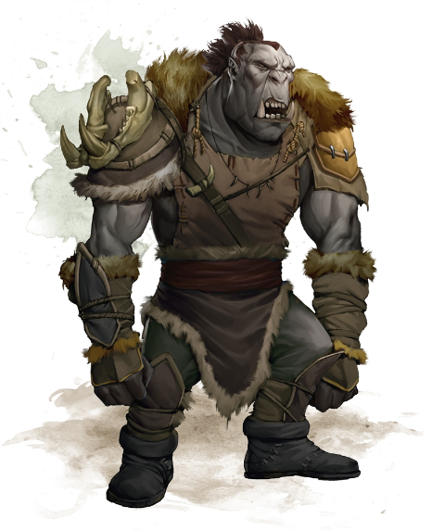

* **Demon bats** are flying enemies that do little damage but are incredibly fast.

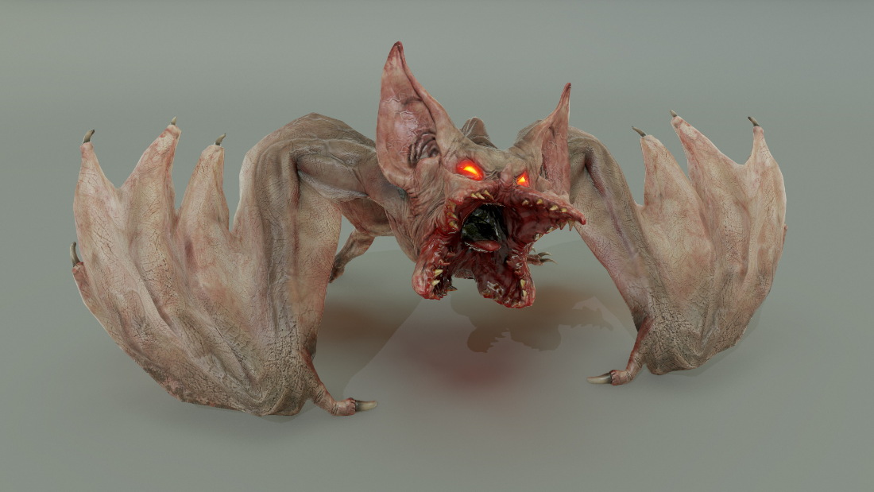

* **Orc militia** are average enemies, balancing speed, and damage. Though not very harmful, they can get overwhelming in groups.

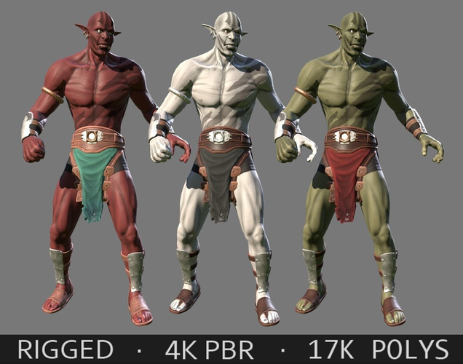

## Merchants

Traveling merchants allow you to trade your collected gold for various items. They can be found in the middle of each level, except the final level. They cannot be killed.

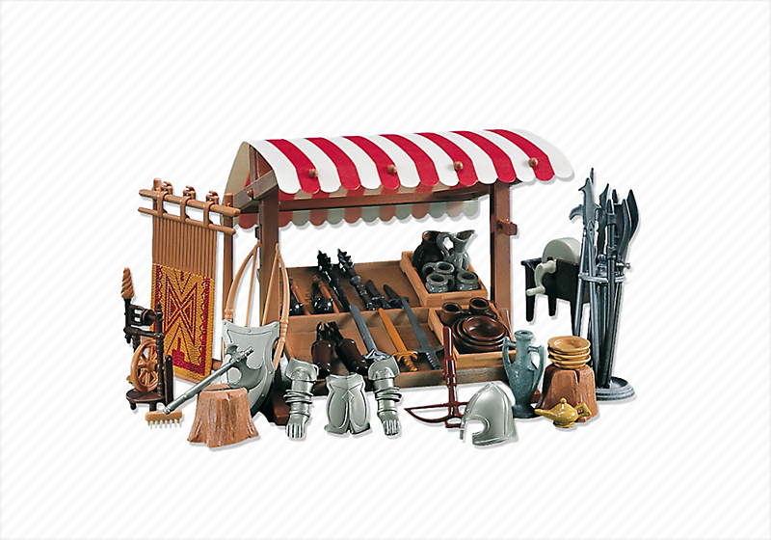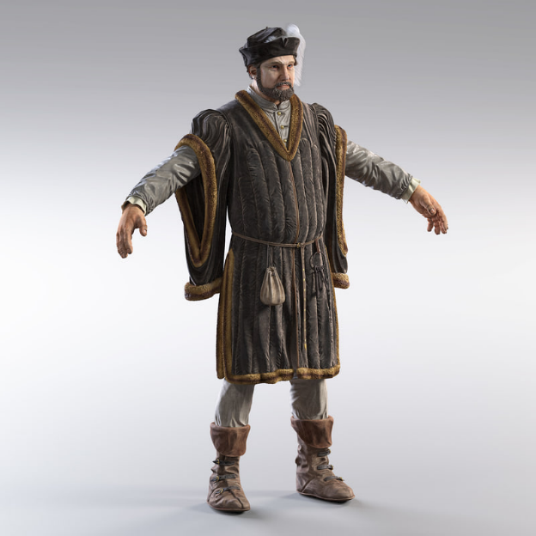

## Boss

The dragon is the boss of the game, the entity the player has been working their way to. The dragon can breathe fire and swing its arms / claws to hurt the player and takes very many hits to be killed.

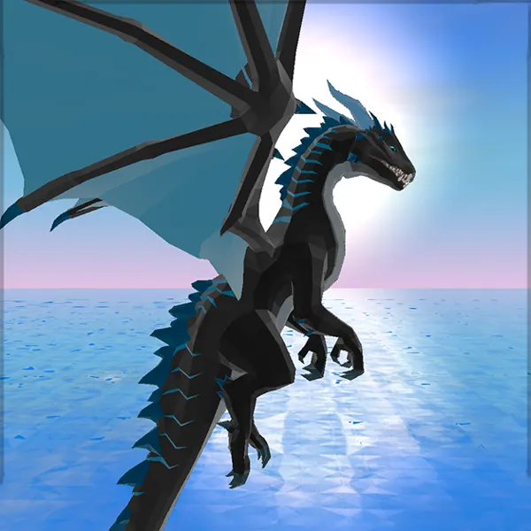

# Weapons

* **The sword** is your first and main melee weapon. If enemies get close, it is more efficient to kill them using the sword, as it does more damage and has more speed.
* **The bow** is your first and main ranged weapon. Being able to shoot enemies from afar, you can kill many monsters before they even get to you.
* **Crates with gunpowder** can be found occasionally across the level, which can be exploded using fire arrows.

# Items

* **The health potion** restores 25% of your health.
* **The strength potion** gives the player a 20% boost in attack damage.
* **The armor potion** gives an addition protection of 15% to armor.

# Armor

* The helmet protects you from attacks on the head with 50%.
* The chest plate protects you from attacks on the chest with 50%.
* Leggings protect you from getting hit on the legs with 50%.

# Cutscenes

The intro cutscene shows the player inside the castle with the king. After learning the dragon is terrorizing the kingdom, the knight is given the order to kill it. The knight can be seen drawing their sword and charge out of the castle.

In the ending cutscene, the knight returns to the kingdom, being recognized as a true hero, for saving all civilians. The civilians are celebrating the death of the dragon.

# Similar products

# Inspiration

